ASSIGNMENT - DIGITAL MARKETING

|  |  |
| --- | --- |
| Reg No | 962820106020 |
| NAME | MAHIBHA J |
| NM ID | 72E4E3913A9EE3DBAEB4D361A937E636 |
| Date | 22-10-2023 |

1.Create a blog or website using Blogspot and WordPress. Customize the theme design and post new article with 500 words.

Link: <http://www.kungfupandaphile.blogspot.com/>

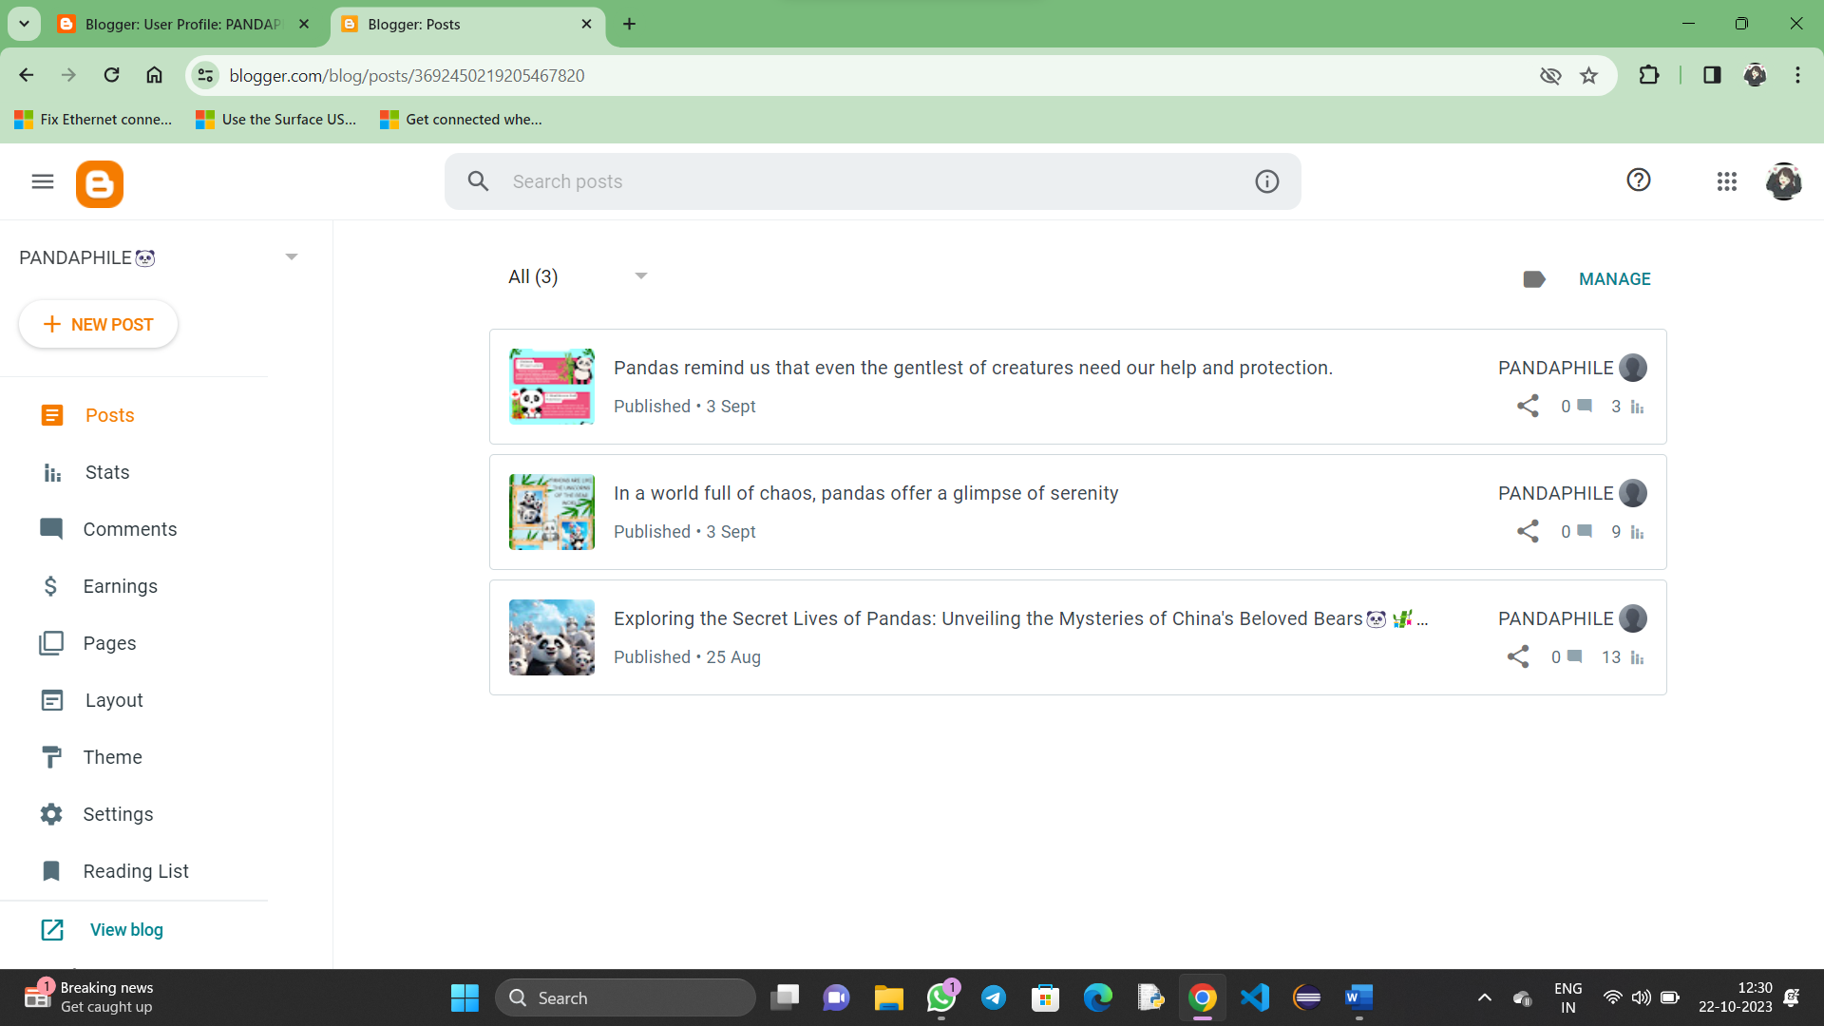

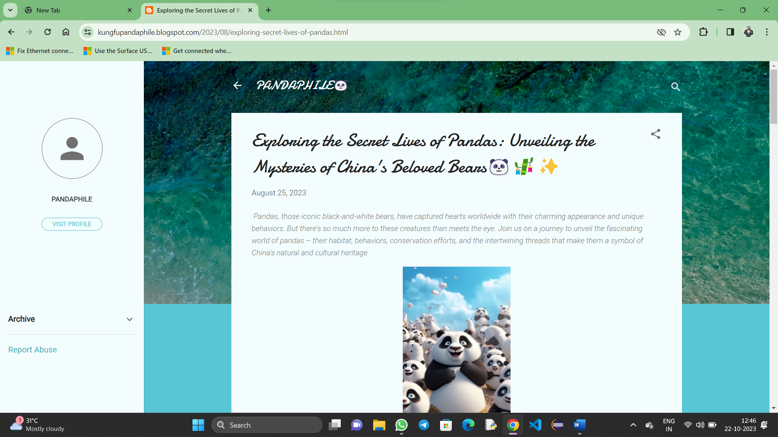

**2**.Create a new Facebook page and post one social media poster for your brand.

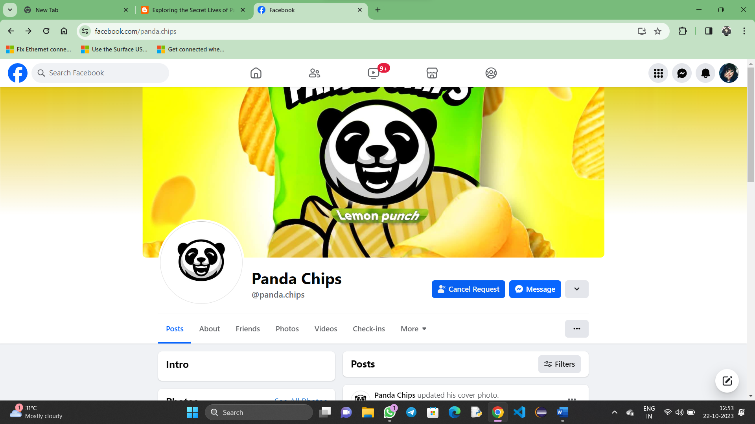Link: <https://www.facebook.com/panda.chips>

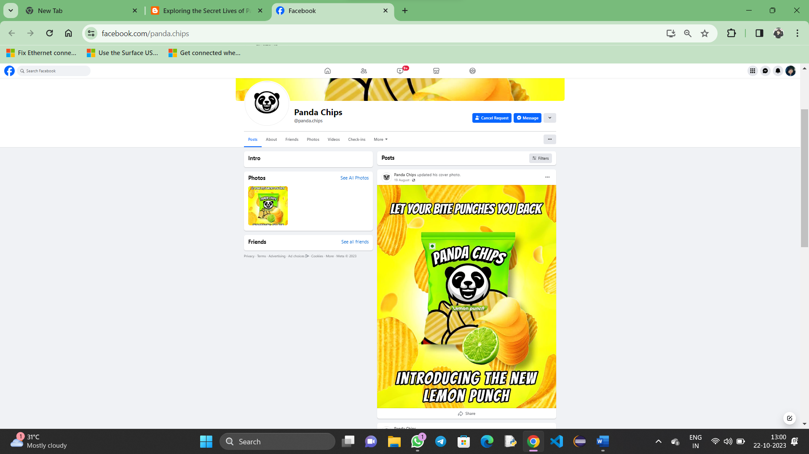

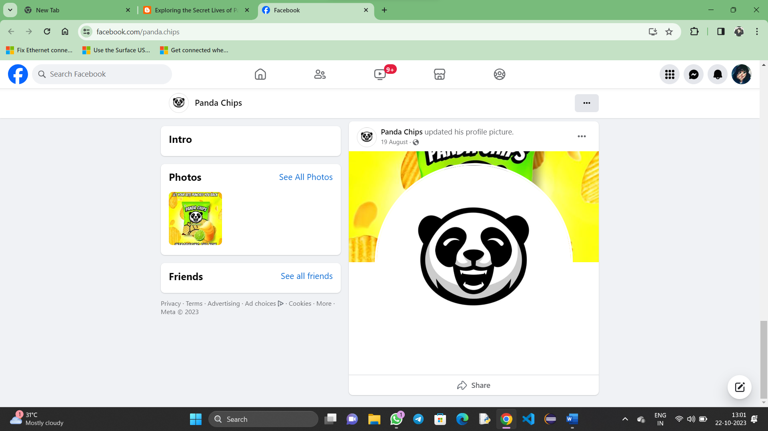

**3**.Create and design a social media advertisement poster using canva

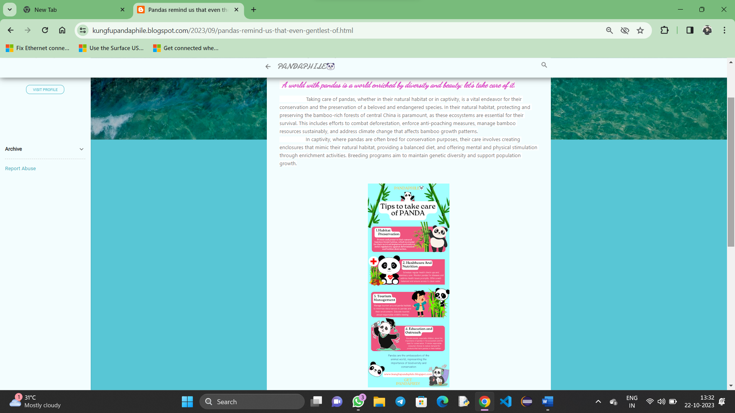 Link: <https://kungfupandaphile.blogspot.com/2023/09/pandas-remind-us-that-even-gentlest-of.htm>

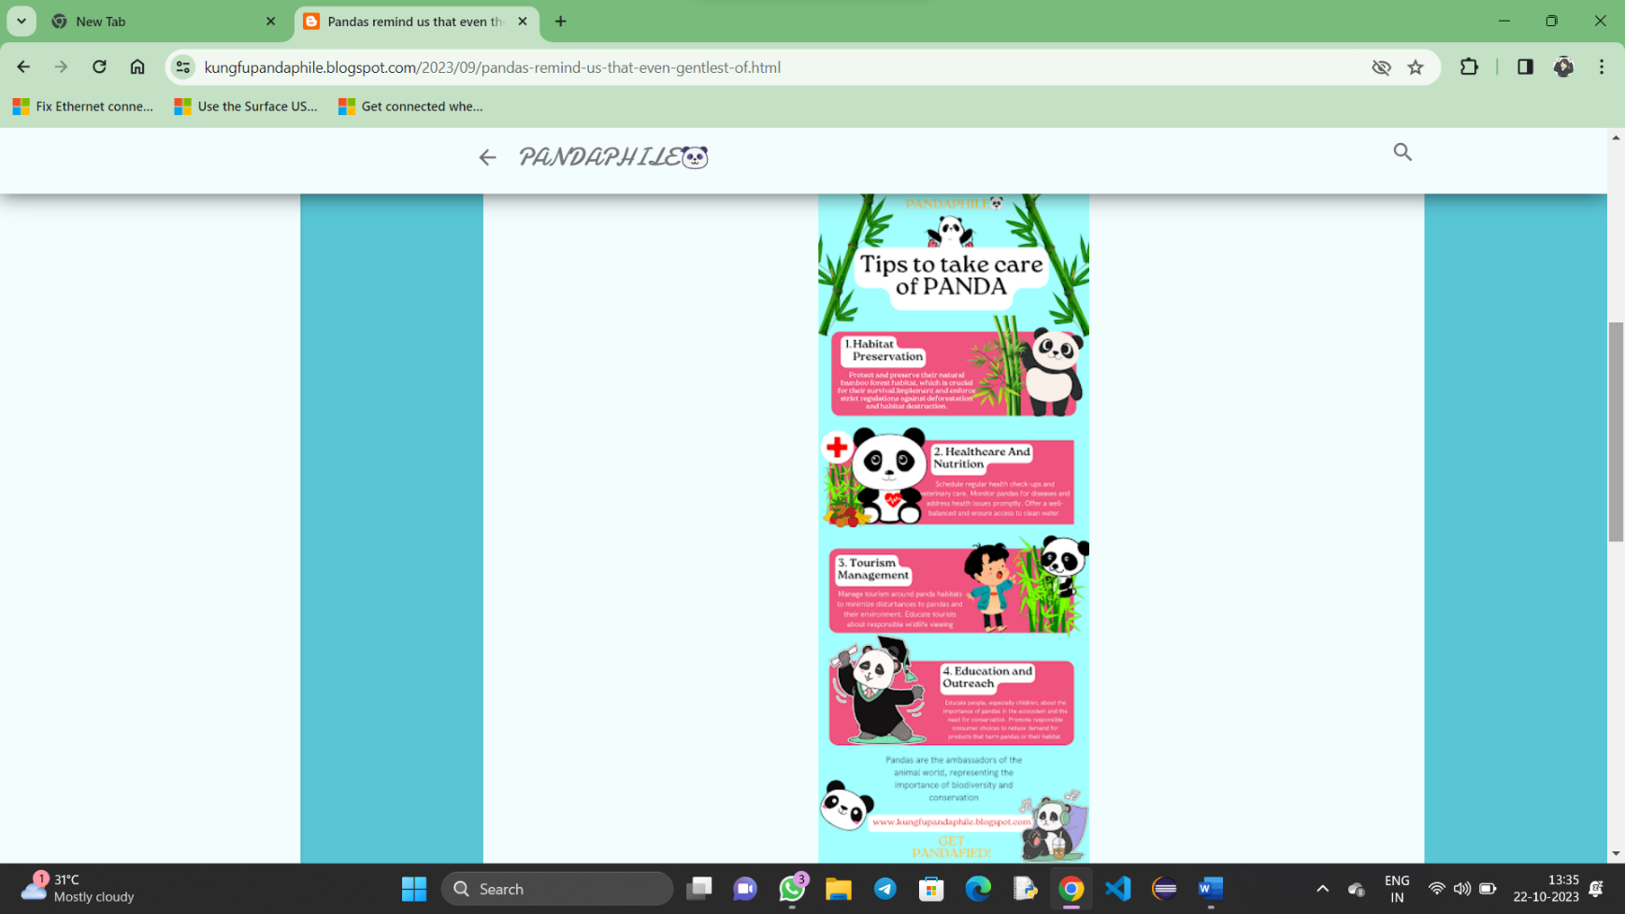

4.Create email newsletter design using MailChimp or canva tool.

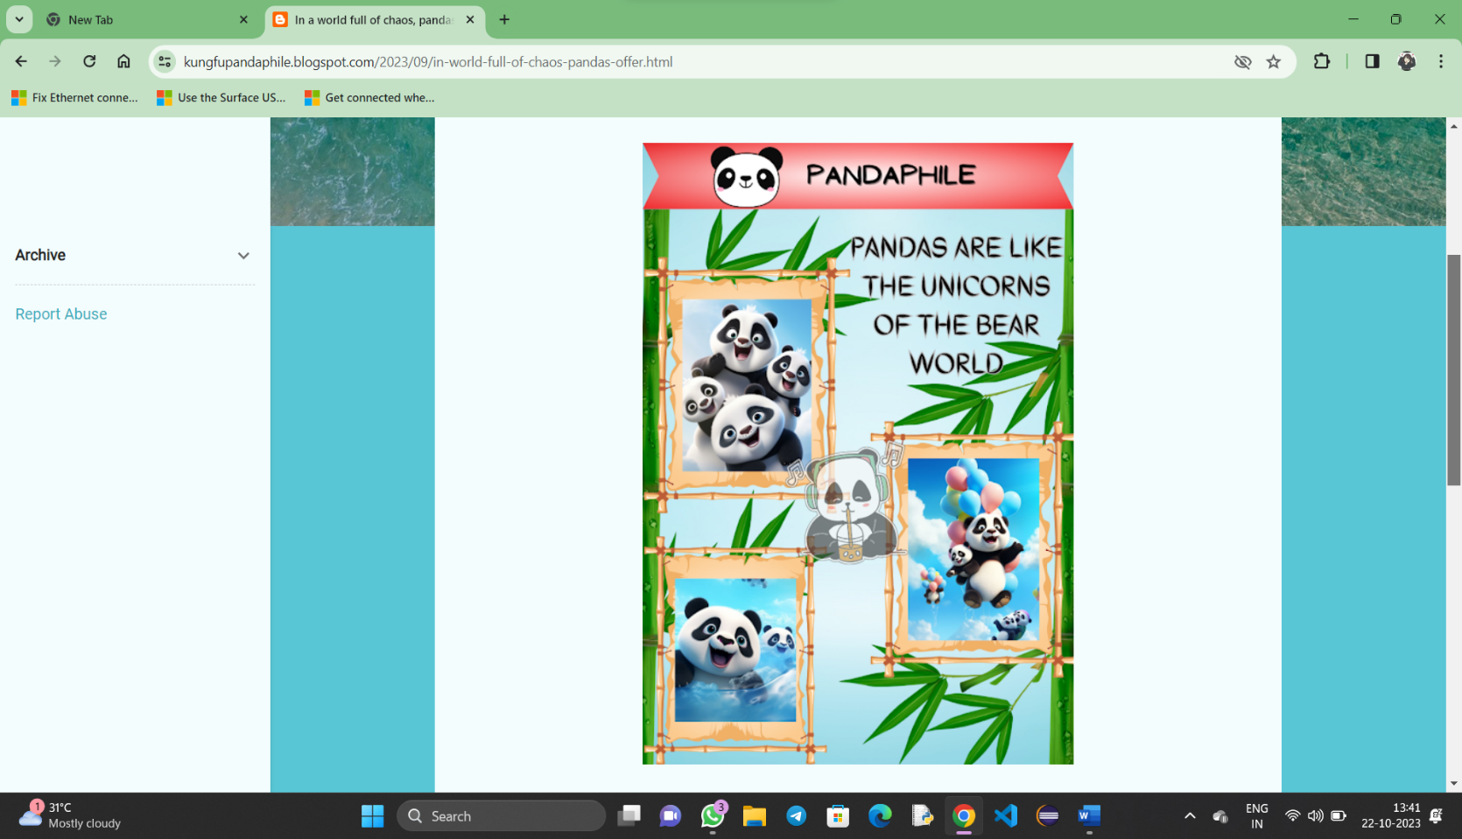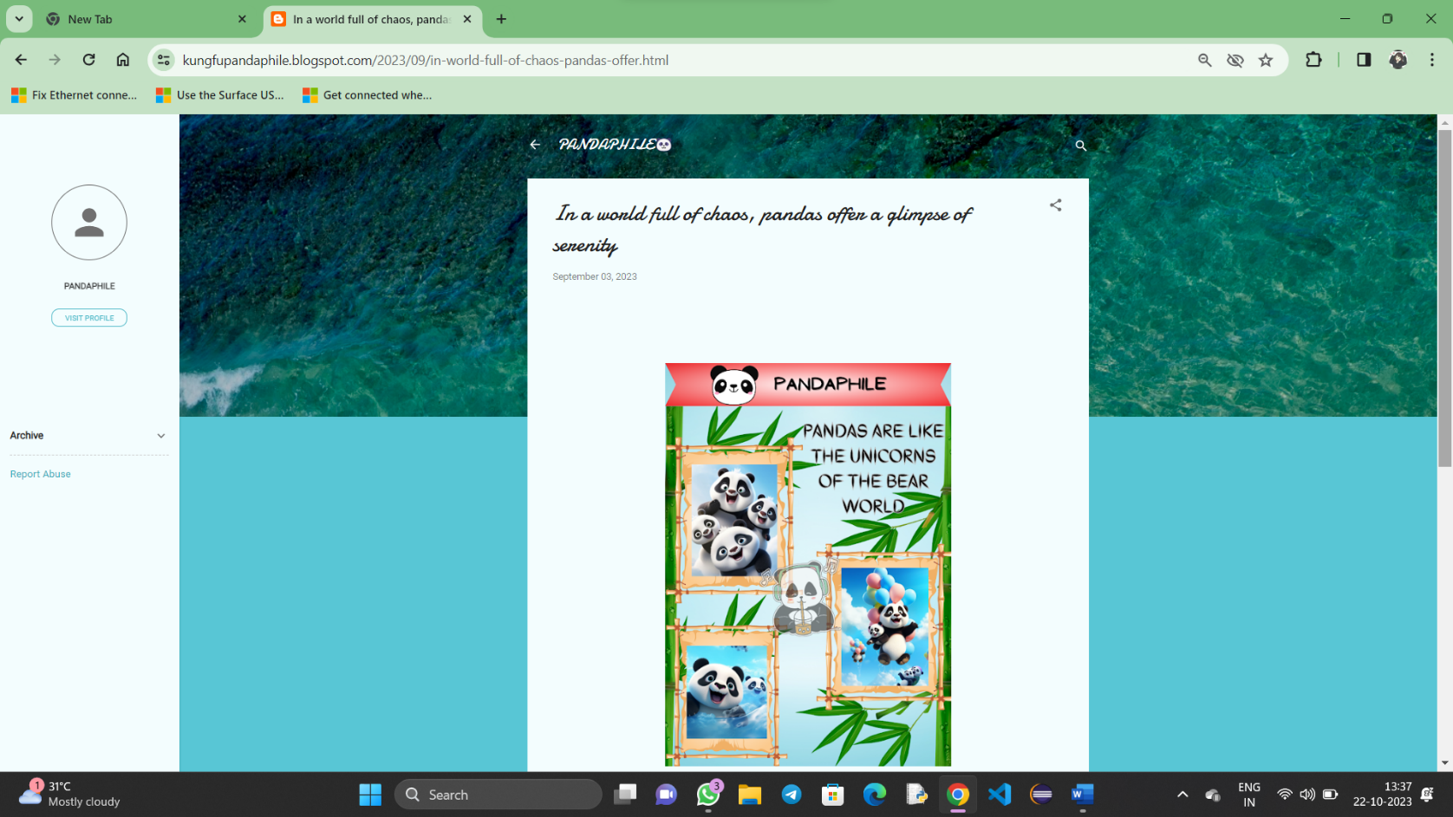Link:<https://kungfupandaphile.blogspot.com/2023/09/in-world-full-of-chaos-pandas-offer.html>